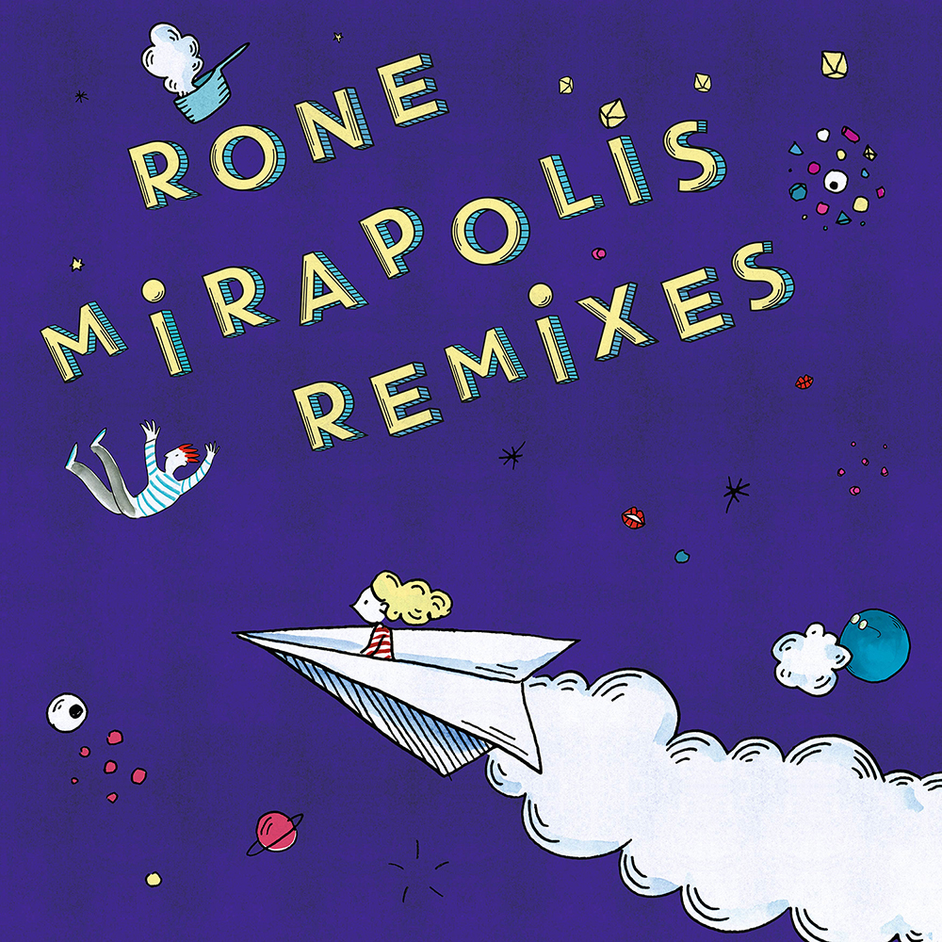

**RONE**

**MIRAPOLIS REMIXES**

**Catalog Number:** iF2072

**Release date:** 05.10.2018

1. Mirapolis (Johannes Brecht Remix) *06:33*
2. Mirapolis  (Matias Aguayo Remix) *06:21*
3. Mirapolis (Laurent Garnier Remix) *09:19*
4. Mirapolis (Video Edit) *03:14*

The flamboyant and off-kilter title track from **Rone**'s latest album, "**Mirapolis**" is one of the last solo tracks that the producer composed in the spring of 2017: *"it's one of the rare tracks on the album for which I thought about the live performance. While putting the final touches to it in the studio, I imagined myself at festivals via memories of previous tours. I wanted to record a festive track, which completely stands by its ‘funfair’ vibe.”* With this new four-track EP (including three remixes), combined with a new video by **Aurélie Castex**, **Rone** extends the carnival of electronic cultures of his latest musical citadel to the dancefloor – and our screens.

**Johannes Brecht**, shadow craftsman of the Hamburg label **Diyanamic**'s studios, offers a refined reading throbbing with cerebral pulsations. Appropriating the main theme in a subtle way, coated with multiple harmonic layers, his textures alternate white noise with organic basses that builds up to a delightfully classical cello outro.

German-based figurehead of the South American scene, **Comeme** label boss and founding member of the late Closer Music project, **Matias Aguayo**, has never ceased throughout his career to set off little revolutions on the planet of demanding dancefloors. Playful and wild, **Aguayo** sweeps in with a ritornello of chiptune sounds and orchestral arrangements, washing it over with a huge wave of analog synthesizers that destroys everything in its path.

French techno scene boss **Laurent Garnier** embraces the original piece in all its meticulousness and its psychedelic lifeblood. A hypnotic and mischievous loop infiltrates itself without warning into the reptilian cells of the listener's brain who surrenders to the ecstasy of the remix, forgetting the futility of everyday problems and tapping into the universal energy of the dancefloor. **Garnier** couldn't have given **Mirapolis** a better gift.

This release of **Mirapolis Remixes** is set to coincide with the release of a new video by **Rone**’s sister **Aurélie Castex**, draftswoman for French magazines like **Elle**. The radiant quadricolour odyssey will be available on Apple Music from August 28, and everywhere else on the Web from September 5.