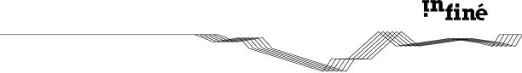
Rone

“Bora”

THE MILK FACTORY_JUNE 2008 (UK)
Ep Review

Link: http://www.themilkfactory.co.uk/st/2008/06/rone-bora-infine-fraction-superposition-infine/

