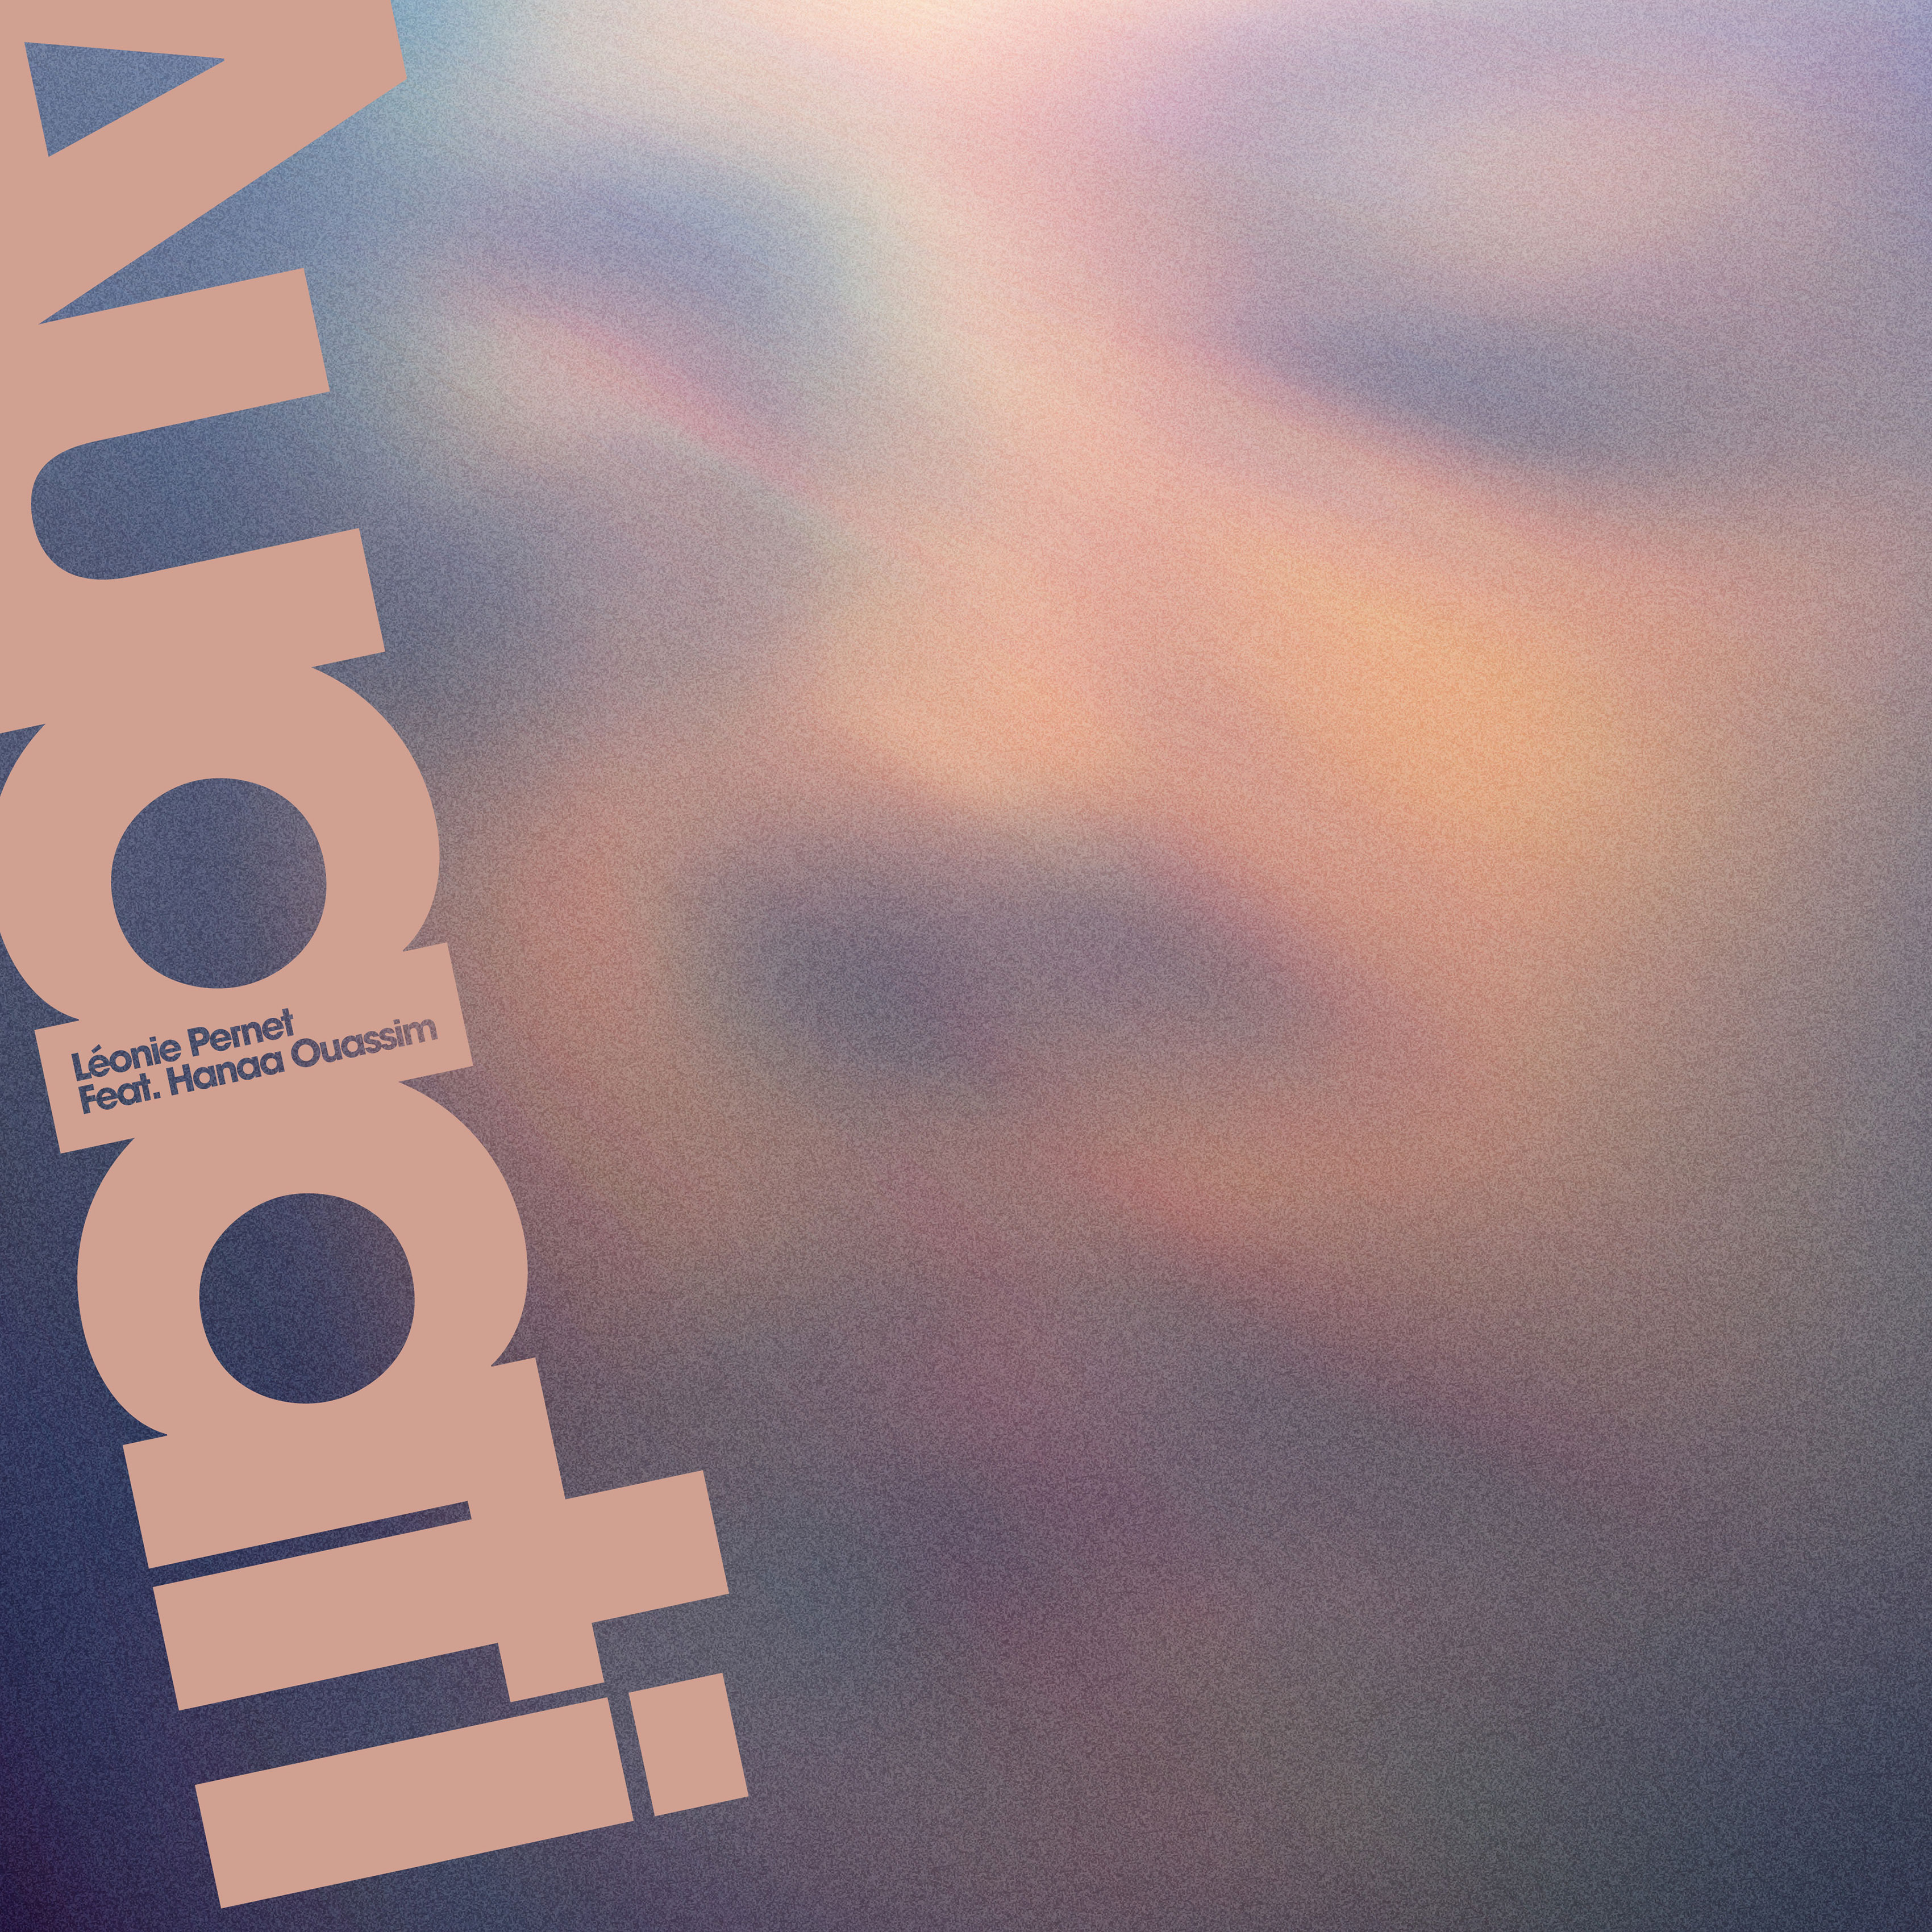

Léonie Pernet

Auaati Remixes - [iF3069]

Release date : 01.03.2019

01 - Auaati (Original Track) 03:32

FR P3F 18 026 60

02 - Auaati (Legowelt Remix) 06:15

03 - Auaati (Acid Arab Remix) 05:31

FR P3F 18 028 30

**Leonie Pernet** offers two new reworks of the sensual and oriental ballad Auaati by oriental sage beat duo Acid Arab and synth sounds' mastermind Legowelt.

**Auaati** is the third extract from '*Crave*,' **Léonie Pernet**'s first album released September 21st, 2018 on **InFiné**, featuring the voice of **Hanaa Ouassim**.

The official video, released in January, is the reunion of two artists' sensibilities, **Léonie Pernet**'s on one hand, whom we know the multiple engagements, and the one of **Lesly Lynch**, a French film director living in NYC, on the other. With their documentary approach, the duo questions the "Muslim queer" identity and celebrate love, while condemning the Islamophobic plague in our post 09/11 world.

It is with the pseudonym **Legowelt** that **Danny Wolfers** has revolutionized the "electro" (strictly speaking) genre since the 90s, by mixing the raw and industrial sound of analogic synthesizers with perfectly calibrated sound designs. After an introduction of the spiritually driven the voice of **Hanaa Ouassim**, the Dutch producer inserts a small loop, precise and effective, in the middle of his listener's brain and takes control of his nervous system. The side effects are immediate: an nodding of the head combined with a big, blissful smile.

**Acid Arab** aka **Guido Minsky** and **Herve Carvalho** moved the electronic music cursor to the west. They divert the codes of oriental music, in general and Arabic in

particular, and associate them with the hardware machinery of modern techno. On their remix of **Auaati** the sounds of the drums clash with its synthesizer layers, and the androgynous vocoders replace the original voice to plunge the listener into the dampness of an underground club at the first light of day.