**LA FRAICHEUR**

**WELTSCHMERZ** [iF3071]

**OUT 2019.05.10**

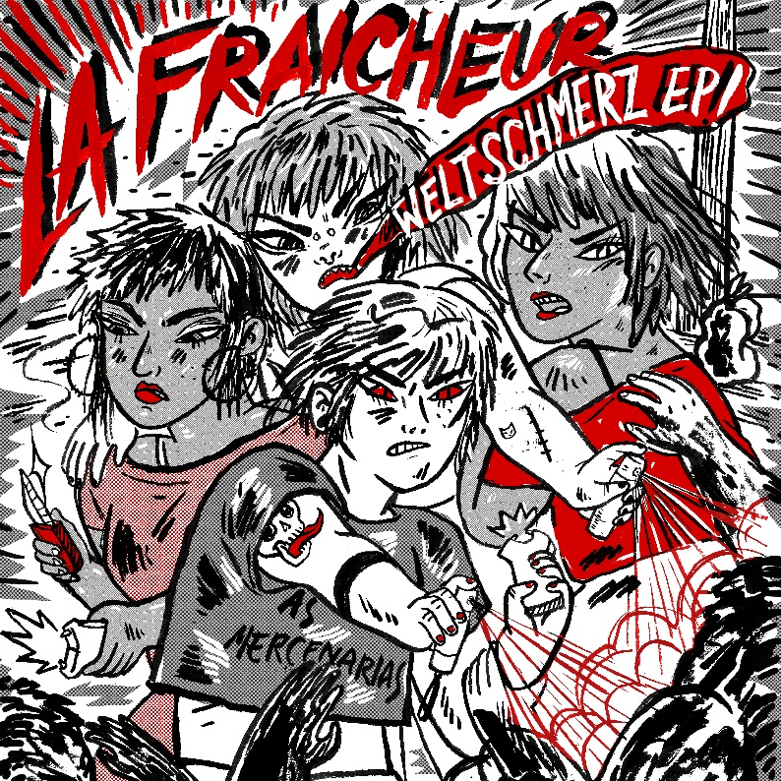

**TRACKLISTING**

1.Quicksand

2.Misanthropy

3.AFOG

4.Weltschmerz

…………………………….

Produced both at her home studio and on tour, between Berlin, New York and Mexico, La Fraicheur wrote the “Weltschmerz EP” following two impulses. One being the desire to make music closer to the “no mercy / take no prisoners” biting sounds of her engaging powerful techno sets, the other the necessity to deal with overwhelming feelings of anger, disgust and frustration born in the backlash following her debut album release and newfound visibility confronting her with the invasive violence of misogynistic trolls.

Hence 4 new tracks with a more distorted sound, at times cutting, at times slimy, often restless and howling, built on the liberating energy of dance as escapist solace and techno as catharsis.

**About La Fraicheur :** For over a decade now, first in Paris, then Montreal and now in Berlin, La Fraicheur has been brewing her own blend of Deep House & Techno beats, making a name for herself with her signature sound of emotionally charged and acid Techno sets.

Former resident DJ in Berlin's renowned Wilde Renate & Mensch Meier before her career took her on the road too often, member of **the Female:Pressure network**, regular DJ at Berlin kink parties Gegen, Pornceptual , House of Red Doors or Buttons, the **queer feminist activist** is a marathon DJ who can go on for countless hours, running the gamut from classics to new songs released just hours earlier.

Expanding her craft by producing her own music ranging from ravy epic Techno to dark pumping Electro, spacious open-air Deep House to melancholic Electronica, she wrote her critically acclaimed debut album during an artist residency with the Berlin-Detroit Connection (organisation founded by Mike Banks (UR) and Dimitri Hegemann (Tresor)) at the **Underground Resistance** HQ in Detroit. Released in June 2018 on French label InFiné, **Self Fulfilling Prophecy** garnered quite a supportive media coverage. She was invited that same year by Roland to launch the TR-8S alongside Steffi, Virginia and Catnapp. She was on the frontcover of Tsugi Magazine in March 2019.