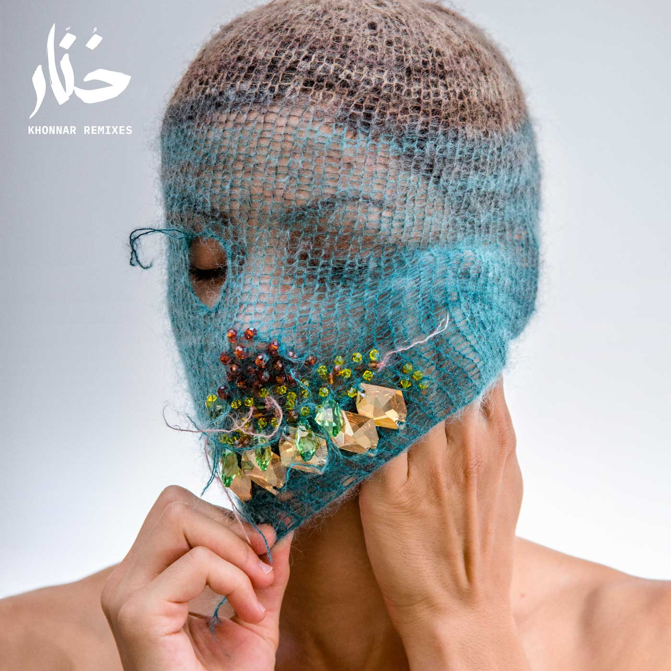

**TRACKLISTING:**

*VINYL*

A1 - Deena Abdelwahed - Tawa (M.E.S.H. Remix) 05:35

A2 - Deena Abdelwahed - Ken Skett (Karen Gwyer Remix) 07:33

B1 - Deena Abdelwahed - Ababab (Ital Tek Remix) 04:34

B2 - Deena Abdelwahed - 5/5 (Lord of The Isles Remix) 06:50

Masks and photos by Judas Companion - Design by Motoplastic

Emerging artists rarely exceed listeners’ expectations with a complete album right out of the box, but **Deena Abdelwahed** is the exception that proves the rule. While the young artist of Tunisian origin stood out with her daring DJ sets, it is her surprising first album, "Khonnar", released at the end of 2018 on InFiné which sealed her status of eclectic producer, guaranteeing her a place among the best releases of the year by Resident Advisor, Trax, Tsugi, The Quietus and Vinyl Factory. Khonnar remixes compiles a series of remixes in 12” and digital formats, inspired by the unique atmosphere of Deena Abdelwahed's first album, while extending it across the entire spectrum of electronic, club and experimental music.

On the A Side of the 12”, “Tawa” is turned over to **M.E.S.H**., already known for his deconstructions of club tropes, to add his propulsive, frenetic avant-garde bass music-inspired beats, highlighting the track’s sense of cultural oppression, leading to the East’s generational boiling point. British producer **Karen Gwyer**’s, adds her Warpian, hardware-heavy analog techno patina to “Ken Skett”, lending it a slightly spooky vibe that develops into a blissful electronica ballad towards the end.

On the B side, Brighton I.D.M. producer **Ital Tek**, who released last year a new masterpiece of Planet MU's discography strengthens up “Ababab”, picturing with his rework a dystopian landscape of dazzling spectral waves, cold rhythmical uprise and futuristic analogic synths. **Lord of the Isles**, remixer of Jon Hopkins, Little Dragon and singular productions for labels as diverse as ESP Institute, Mule or Phonica, offers us with his remix for “5/5” a post-apocalyptic ride between solar techno dub and immersive minimalism.